**14-Apr-2020**

1. **How to write a shell script, How to save & How to come out of the shell scripting file**

nano hello.sh

---

---

Cntl o + Enter = Save

Cntl x = exit from file

1. **How to run a shell scripting file**

./hello.sh

1. **How to write combination of commands using && operator**

Example1:

nano hello.sh **&&** chmod 700 hello.sh

#!/bin/bash

echo "Hello Raj"

echo " Welcom Raj"

echo "Nams

Example2:

nano hello1.sh **&&** sleep 10 **&&** chmod 700 hello1.sh

#!/bin/bash

echo "Hello Raj"

echo " Welcom Raj"

echo "Nams

1. **How to use Variables**

use always captial letter for variable declaration

NAME="Ragz"

NAME='Raghav'

Run this command

echo $NAME

AGE=36

echo $(AGE)

1. **What is Interpolation**

Example1:

#!/bin/bash

NAME1="Anand"

NAME2='Balu'

echo "Hello $NAME1" --**interpolation**

echo "Welcome $(NAME1)"

echo 'Namaste $NAME2'

echo 'vanakkam $NAME2' --it considered as complete string

Example2:

#!/bin/bash

NAME1="Anand"

NAME2='Balu'

echo "HEllo $NAME1" --**interpolation**

echo "Welcom $(NAME1)" --**interpolation**

echo "Namaste $NAME2" --**interpolation**

echo "vanakka $NAME2" --**interpolation**

1. **How to find python is installed or not**

Command : which pip



1. **Install Python in UBUNTU**

Command: apt update && apt install -y python3 cowsay



1. **What is Cowsay Command?**

Just look and feel purpose in shell scripting ☺

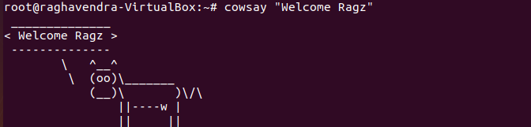

1. **How to find version**



1. **How to check AWS CLI is installed or not**



1. **How to install AWS CLI**

Command : pip3 install awscli --upgrade (python installer packer)

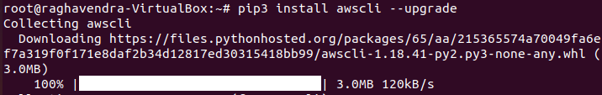

1. **Check, is AWS is installed?**

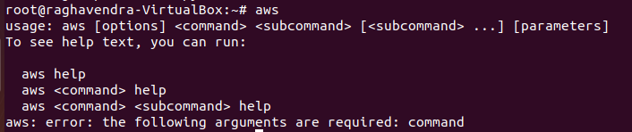

1. **Configure AWS**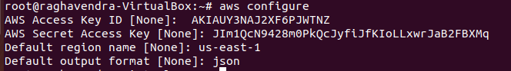
2. **Verify is AWS CLI is installed or not?**

Execute any AWS CLI Command

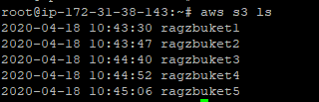

1. **Create a sample test user**



1. **Verify user is added or not**



1. **Grep (Granular regular expression) used for searching a pattern.**

Find out , is testuser is existed or not?



1. **Find out first word of the output from grep**

cat /etc/passwd | cut -d ":" -f 1



1. **For more words in the same filen(1,2,3,4..n) parameters**



1. **Display all the users in /etc/paswd directory**

USERS=$( cat /etc/passwd | cut -d ":" -f 1)

echo $USERS



1. **Display user one by one**



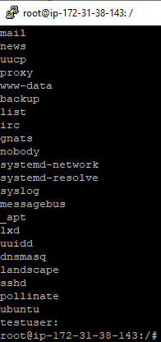

1. **Command for describing EC2 instance**

Command: aws ec2 describe-instances

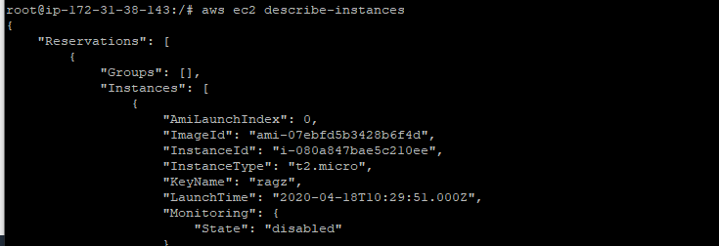

1. **List of instance in AWS EC2 for a particular account**

**aws ec2 describe-instances | grep -i InstanceID**



1. **How to get the 2nd parameter, so that it can display Instance id.**

aws ec2 describe-instances | grep -i InstanceId | cut -d ":" -f 2



1. **How to remove double quotes, comma using TR command (**alternatively we can use “sed” command as well to remove unwanted letters)

aws ec2 describe-instances | grep -i InstanceId | cut -d ":" -f 2 | tr -d '"'| tr -d ','



1. **How to STOP EC2 instance from AWS CLI**

Currently 3 EC2 Servers are running, make it stop

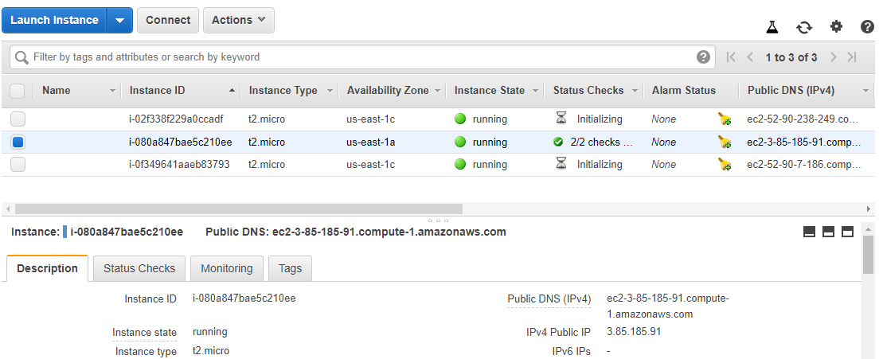



**Execute below commands to stop all 3 servers.**

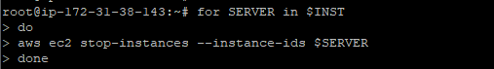

**Below is the immediate execution result**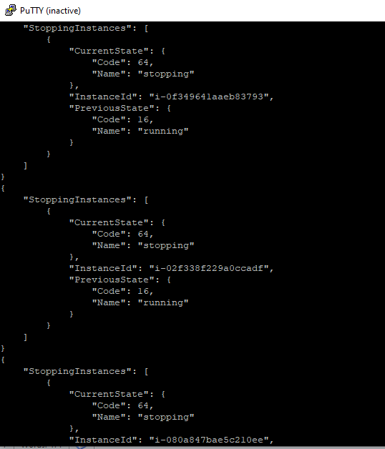

**Immediately current session got terminated as expected.**

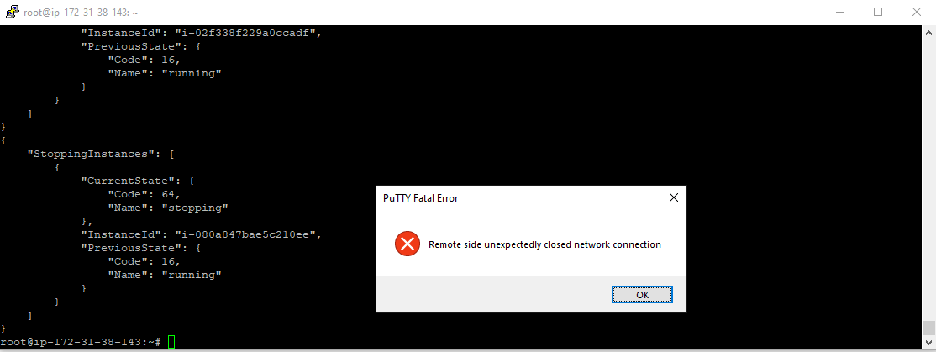

Note: The valid values for instance-state-code you can observe that what was previous status & what is current status.

0 : pending

16 : running

32 : shutting-down

48 : terminated

64 : stopping

80 : stopped

**All got Stopped.**

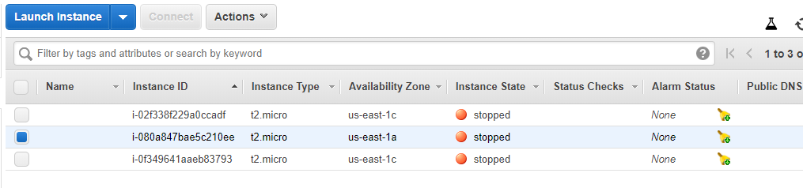

1. **How to START EC2 instance from AWS CLI**

**Two instance are running status, purposefully we shall stop one server from GUI ,restart from CLI**

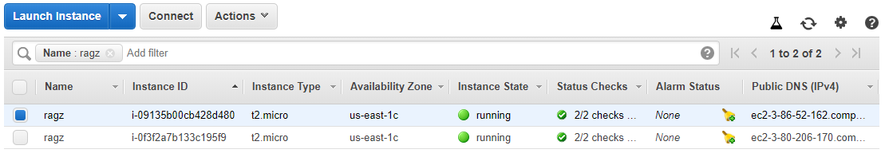

**Stopped one server from GUI.**

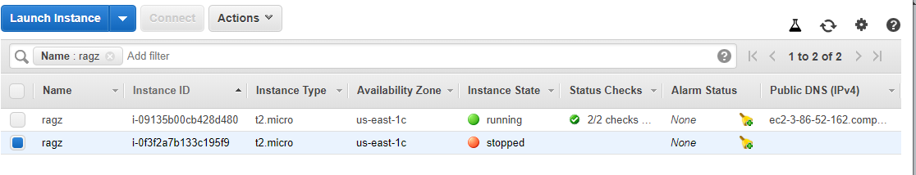

**aws ec2 start-instances --instance-ids** i-0f3f2a7b133c195f9

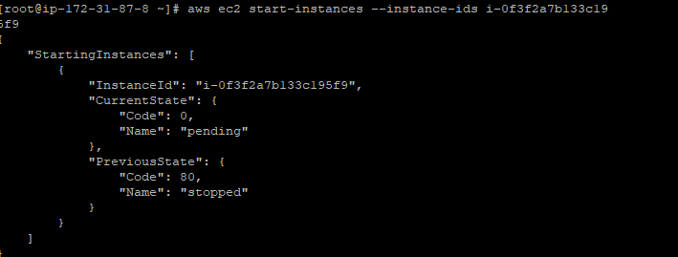

**Initialising**



1. **How to REBOOT EC2 instance from AWS CLI**

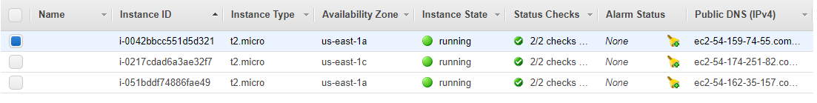

**INST=$( aws ec2 describe-instances | grep -i InstanceId | cut -d ":" -f 2 | tr -d '"'| tr -d ',')**

**for SERVER in $INST**

**do**

**aws ec2 reboot-instances --instance-ids $SERVER**

**done**

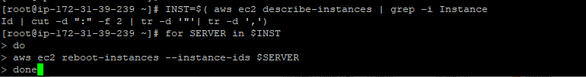

**Immediately below window pops up as because its rebooting**

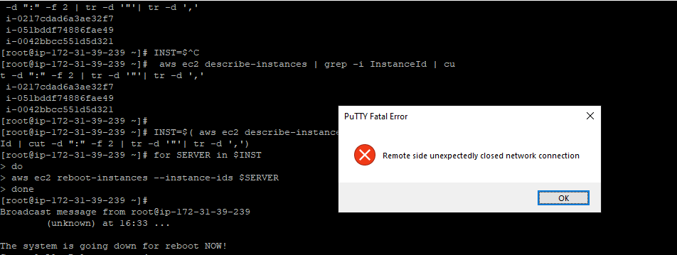

1. **How to TERMINATE EC2 instance from AWS CLI**

**INST=$( aws ec2 describe-instances | grep -i InstanceId | cut -d ":" -f 2 | tr -d '"'| tr -d ',')**

**for SERVER in $INST**

**do**

**aws ec2 terminate-instances --instance-ids $SERVER**

**done**

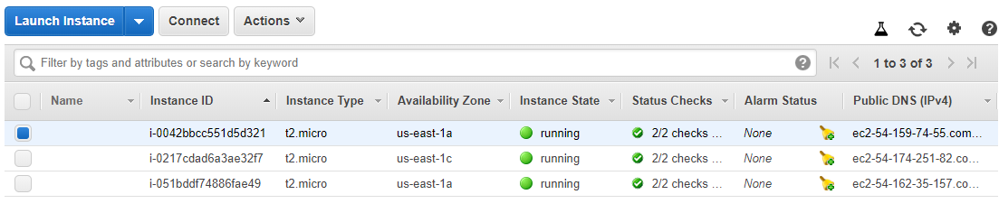

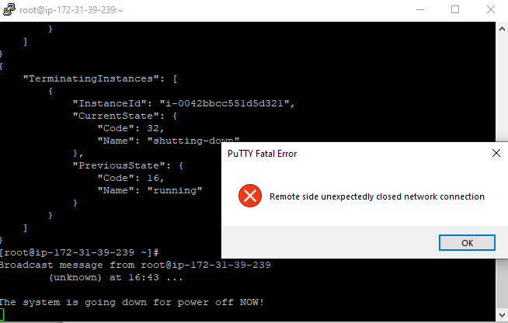

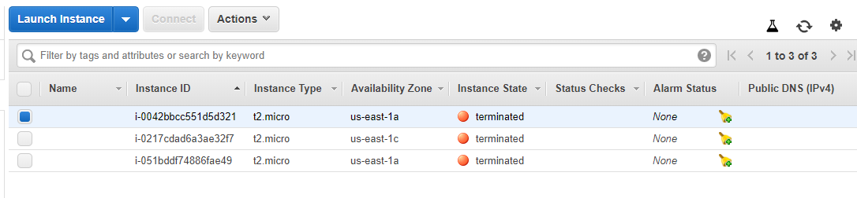

1. **How to create S3 bucket**

**I=1**

**while [ $I -lt 6 ]**

**do**

**aws s3api create-bucket --bucket devops12bucket$I --region us-east-1**

**I=$(( $I + 1 ))**

**done**

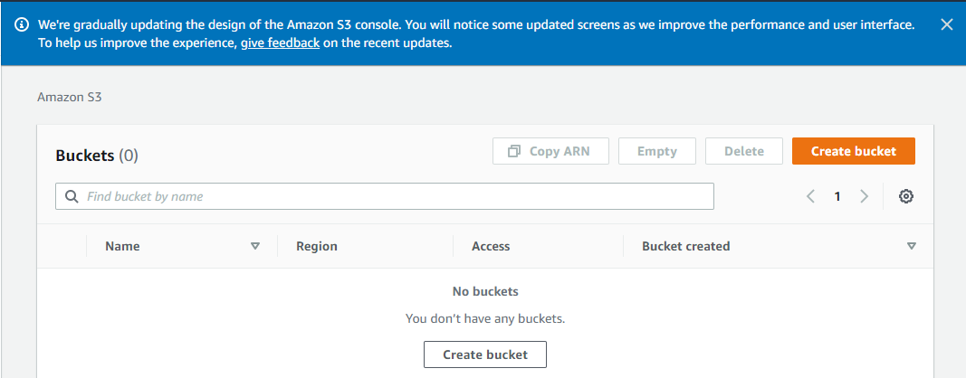

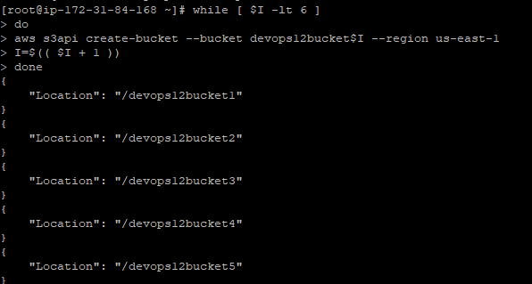

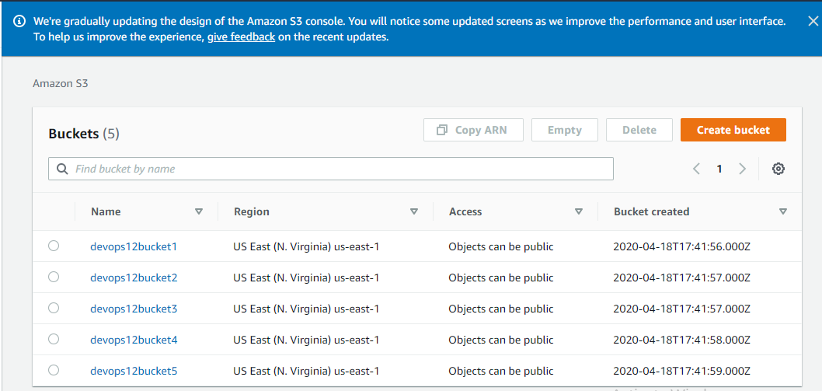

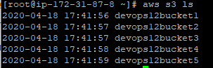

1. **How to delete S3 bucket/file**

**I=1**

**while [ $I -lt 6 ]**

**do**

**aws s3 rb s3://devops12bucket$I --force**

**I=$(( $I + 1 ))**

**done**

**Removing all the S3 buckets**

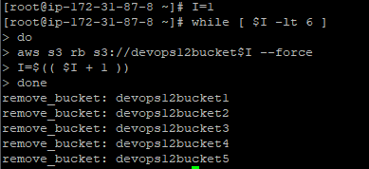

**Removed all the buckets, as expected**

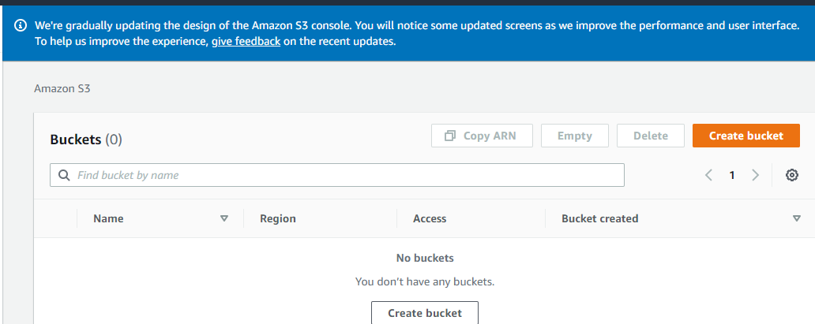

1. **Where will access key and scret keys will be storing**

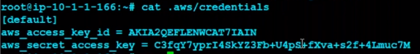

1. **How to set PATH in Linux, how to find file is from which location**

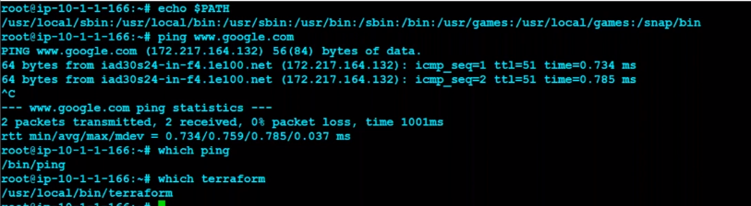

1. **If move files to below directory , then no need to give ./ while executing**



1. **From which path file is executing**



1. **When we want to declare as global access key and global secret key for multiple applcaiton access we can leverage Export command**





